Kayla Day

Layout change and added a second list

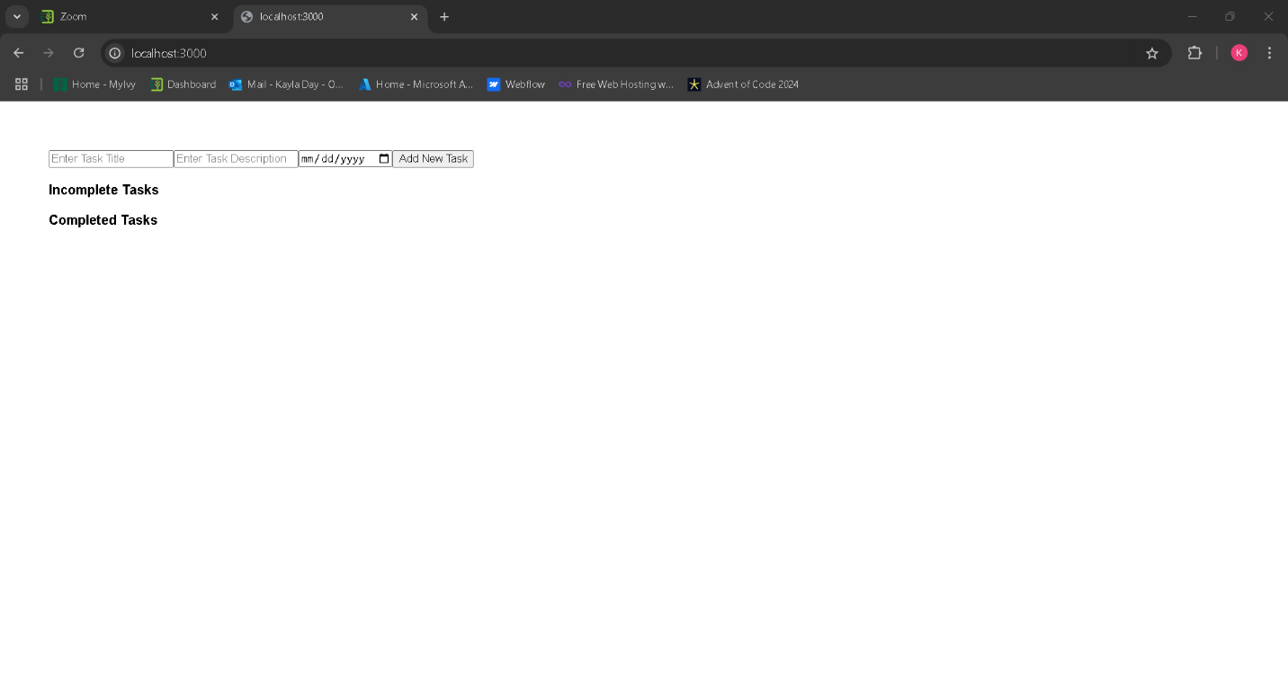

Adding new tasks to the list

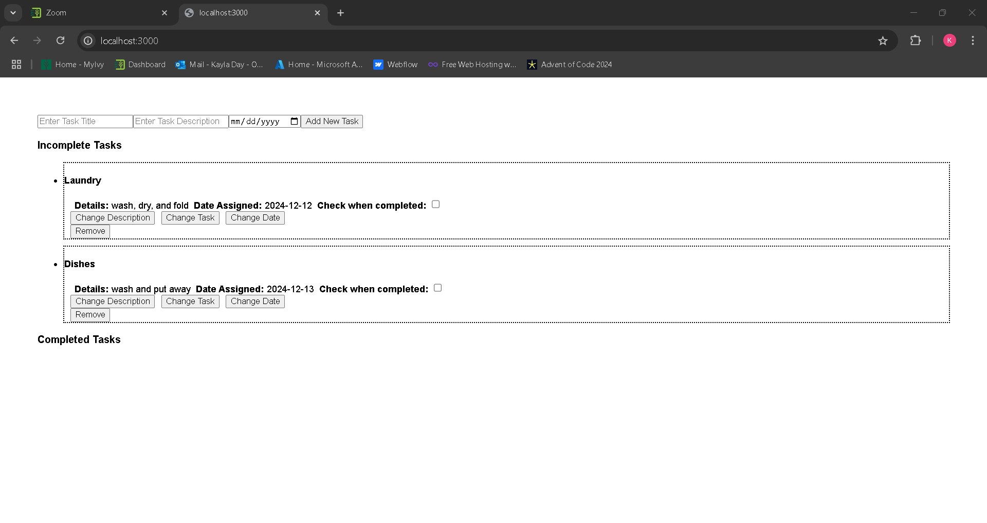

Buttons appear under the fields and provide input fields when pressed.

Checking the checklist moves the task into a new list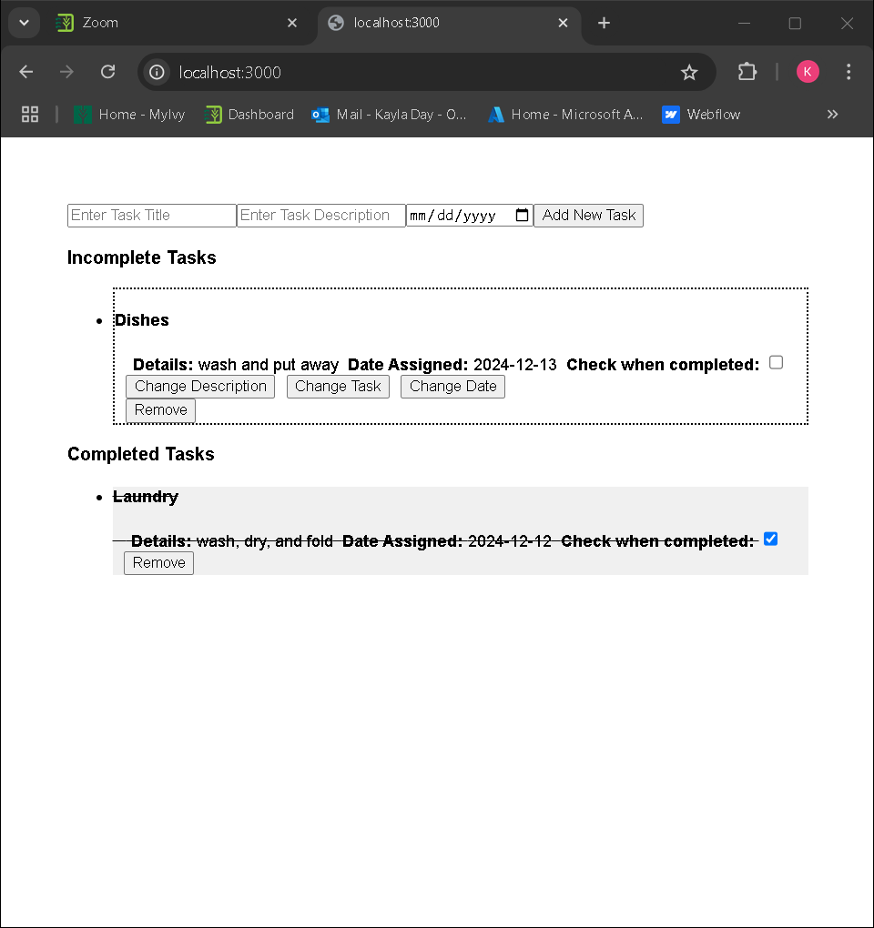

Remove button removes task

